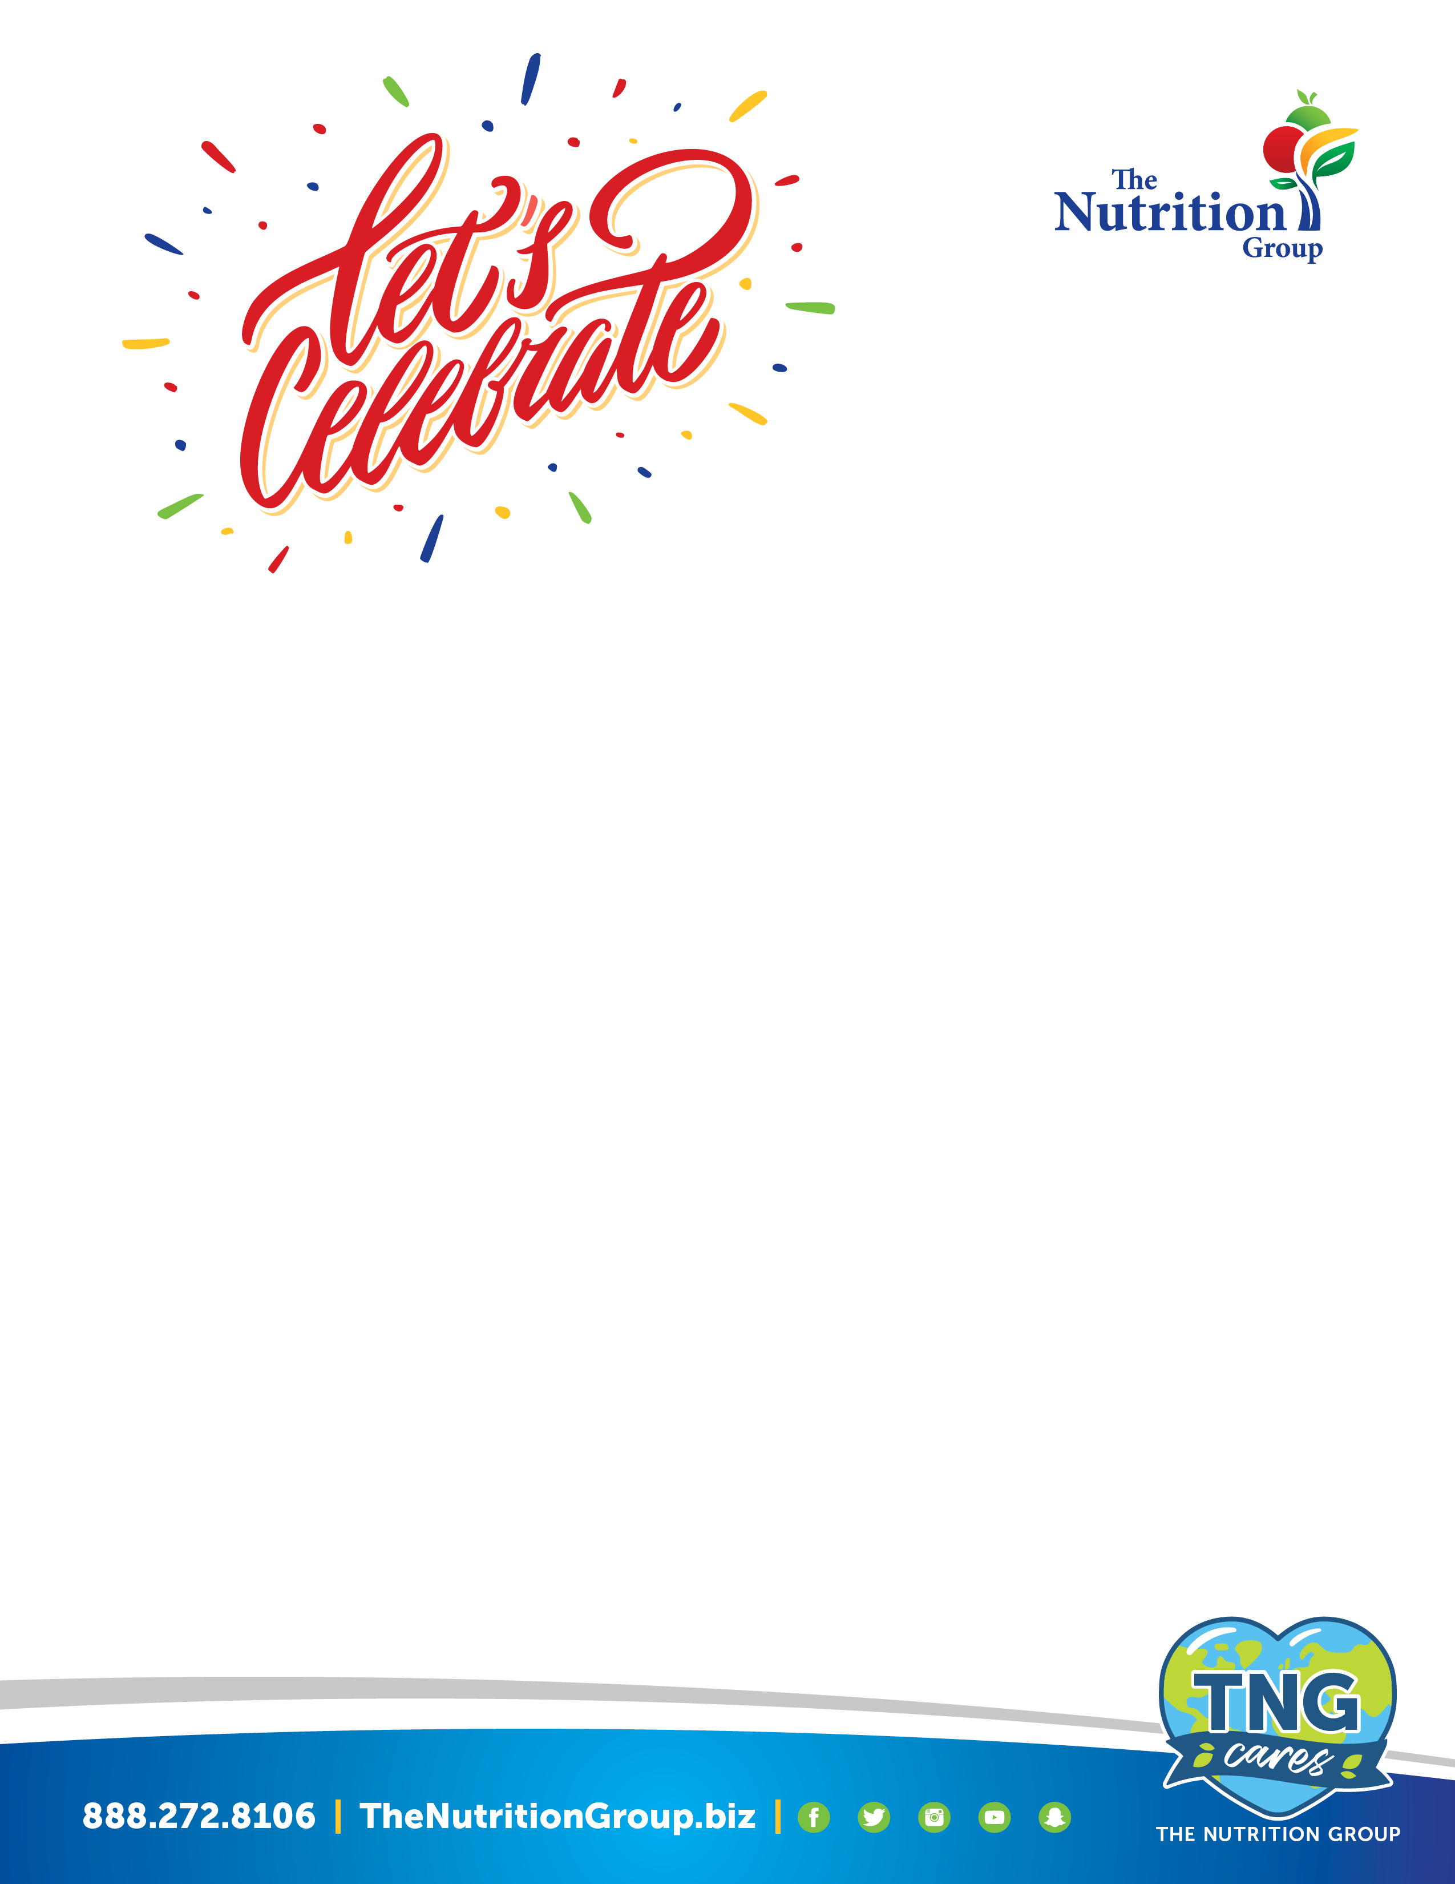

Create Your Very Own

Classroom Celebration!

Fresh Baked Cookies $0.50 each
Soft & chewy wholegrain cookies, choose from Chocolate Chip, Carnival or Sugar cookie.

Festive Rice Krispies Pops $1.50 each
Individually wrapped sweet and delicious wholegrain treat on a stick dipped or drizzled in either vanilla or chocolate icing and topped with festive sprinkles.

Hershey’s Ice Cream Cups $1.25 each

Hershey's Ice Cream Scooter Bar $1.25 each

Hershey's Fudge or Fruit Punch Bar $1.00 each

Individual Fruit or Veggie Snack $0.75 each
Bagged apple slices -or- baby carrots with ranch dip

Assorted Individual Snack Bags $1.00 each
Individual bags of Baked Chips, SmartPop!® Popcorn, Kids Munchie Mis or Doritos,

8oz Bottled Water, Milk or 4oz Juice $0.50 each

All choices are wholegrain or low fat and napkins are provided.

Please provide a minimum 1 week notice for all Celebration orders.

To order contact:
Amy Hehn, RDN
Director of Food & Nutrition
Tamaqua Area School District
570/668/0979
nutrition@tamaquasd.org

